Vector Semantics and Word Embeddings

Source: https://people.ischool.berkeley.edu/~dbamman/nlp20_slides/8_vector_semantics.pdf

Distributed Representation/word embedding
- Vector encoding distribution of contexts word appears in
- Term-document matrix (size proportional to #documents)
- Term-context matrix (appearance of term within context/directional n-gram)
- Similarity
  - Euclidean (measures magnitude)
  - Cosine: (measures orientation)
  - Levenshtein (for strings)

TF-IDF
- Feature scaling

Independence of terms
- Pointwise mutual information:

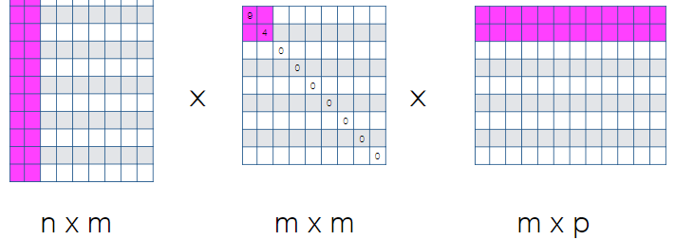
Dimensionality reduction
- Singular value decomposition
- Latent semantic analysis: term-document matrix → TF-IDF→ SVD
- Skipgram model: given single word in sentence, predict words in context window

Pre-trained embeddings
- word2vec
- glove

